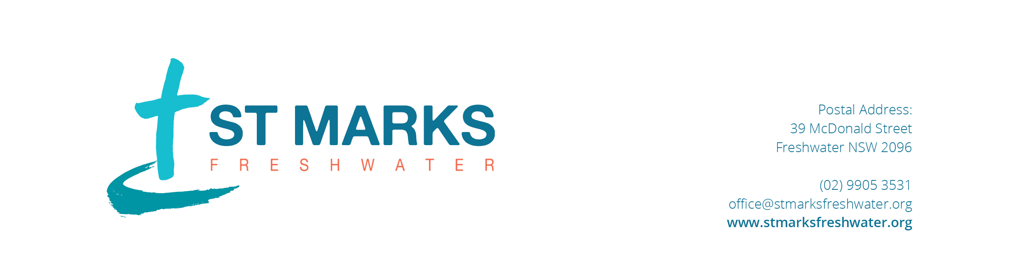

Privacy Policy

St Marks Anglican Church is exempt from the requirements of the Privacy Act as a “small business”. However, to respect your privacy, we will seek to deal carefully with any personal information we collect and retain in the manner set out in this policy.

Collection of Information
We collect and retain information needed for the ministry and related activities of St Marks Anglican Church.

We may ask for general information about you such as your name, address and other details so that we can contact you, provide services to you or for the purpose of your participation in church activities. The information collected may include some sensitive information such as health information, your religious beliefs and so forth. Where practicable, the reason for collecting personal information will be made clear at the time of collection.

You are not required to give us any personal information. However if you do not provide us with certain information we may not be able to provide you with access to some of our services or allow you to participate in some of our activities.

Use and Disclosure of Information
We use information only for the purposes we have disclosed at the time of collection, or otherwise as set out in this Privacy Policy. We will not use or disclose your personal information for any other purpose without first seeking your consent, unless authorised or required by law.

We will not mention any sensitive information provided to us, such as health information, in newsletters or bulletins without your approval (or the person responsible for you). Generally we will only use and disclose your personal information as follows:
- to maintain a record of your involvement and attendance,
- to facilitate your participation in the activities of the Church,
- to care for you pastorally,
- to answer your questions,
- to keep you informed of news about the Church and new developments we believe may be of interest to you, and
- to publish a directory of Church members to those participating.

Information Quality
We will endeavour to keep your personal information complete, accurate and up to date.

Information Security
We will take reasonable steps to keep the personal information which we hold secure and to protect it from unauthorised disclosure and misuse.

Access and Correction
We will generally provide you with access to your personal information and take reasonable steps to correct information which is inaccurate, incomplete or out of date. To request access to the personal information that we hold about you please contact the Wardens. If you wish to have your personal information deleted please let us know and we will delete that information unless we need to retain it for our purposes or to comply with the law.

Questions or complaints
Any questions about this Privacy Policy or complaints about our handling of personal information should be directed to the Wardens.

